HLM Drop Down Guide

Data set up:

* You’ll need to make sure each participant’s data piece get it’s own line (instead of column + line)
  + For example, if you have participant, 3 times, and two outcomes (DVs)
  + Participant Time DV1 DV2
  + 1 1 12 13
  + 1 2 14 15
  + etc.
* My example here has
  + Participant word(real/fake) typability (easy/hard/etc.) rating (DV)
  + So there are lots of lines – one for each rating they made (120 for each participant).

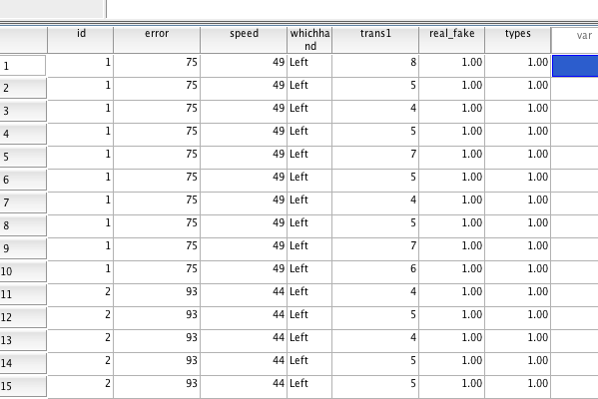

ID = participant number (you need this!)

Error/speed = we actually did a covariate analysis controlling for typing speed, so you can use continuous measures

Trans1 = DV = rating of words

Real_fake = one IV for type of word shown

Types = how easy/hard it was to type

So, we analyzed it as a 2 (real/fake) X 6 (how easy/hard to type, 6 categories) Mixed Model ANOVA (same idea as HLM).

Analyze > mixed model > linear

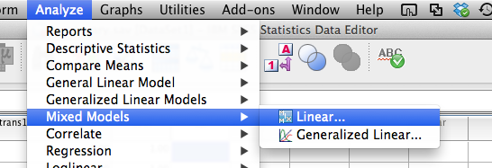

Subjects = participant variable

Repeated = anything you repeated across participants you DO NOT want to analyze (for instance, we controlled for the fact that participants all saw the same words in the original analysis, but I don’t think you’d have this … you did “repeat” times, but you are wanting to analyze that variable).

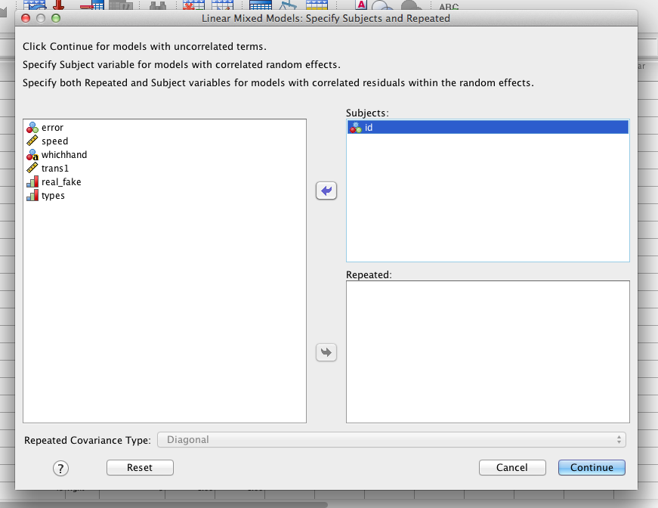

Hit continue.

Now you’ll see a mostly normally looking ANOVA box.

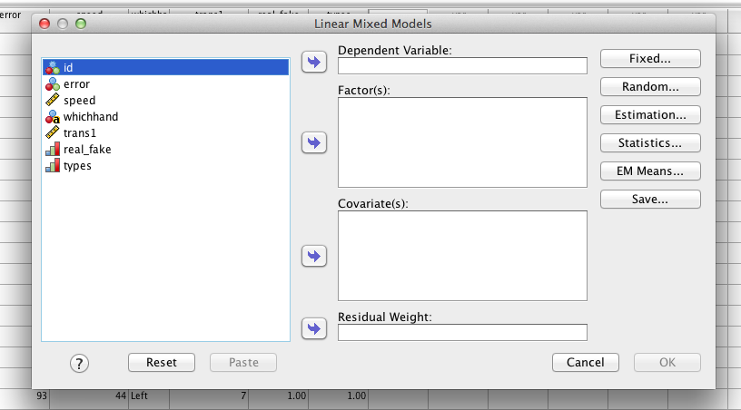

Put the DV in the dependent box.

Put categorical variables in the Factor(s) box.

Put continuous variables in the covariate box (time should probably go here).

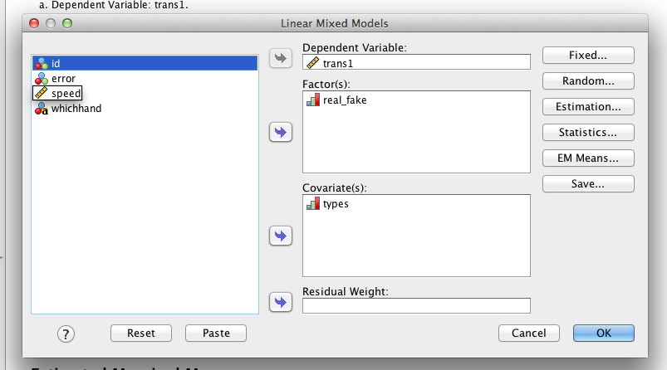

(our type variable wasn’t really continuous, but pretend with me here).

Hit fixed.

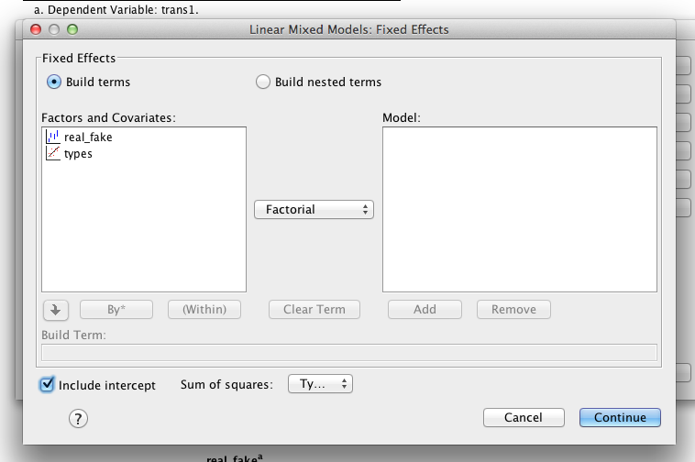

This box lets you build different models. You probably want typical ANOVA style, so you want to click on the variables you want, which will bring up the ADD button – be sure to click it. If you wanted only main effects (i.e. no interactions), then just click main effects (under factorial drop down), etc.

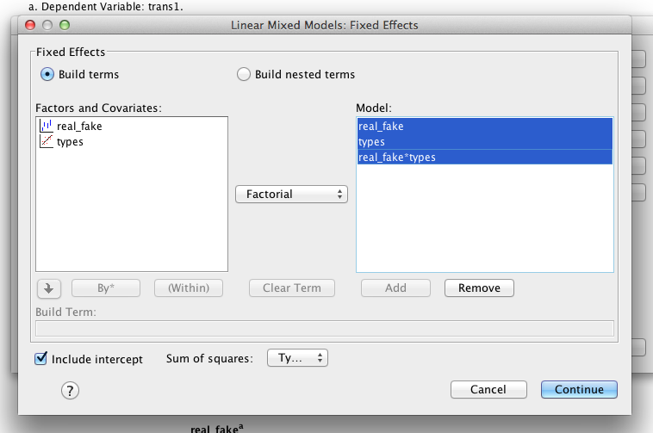

Hit continue.

Hit random. Here are the different covariance types you can try (see other worksheet).

Mostly people just want to include a random intercept (click include intercept) and often treat a time variable as random (I don’t have that, but you would…to get a random time variable, click on time under factors and covariates 🡪 click add). Also move over your subject variable.

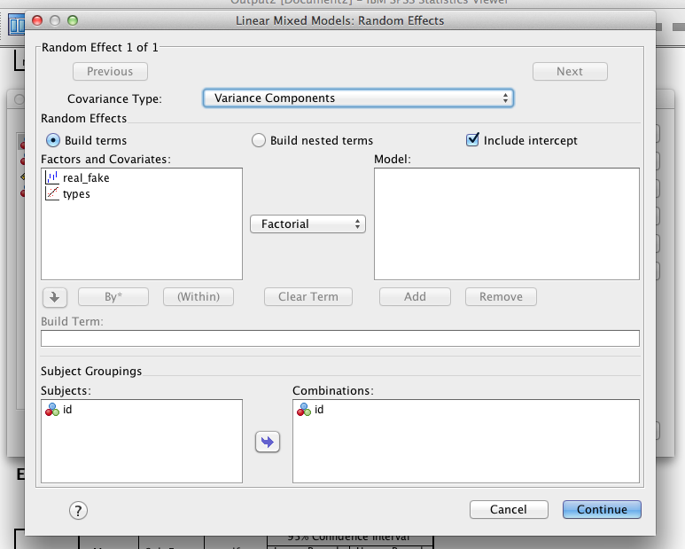

Click continue.

Under statistics, click parameter estimates and covariance test.

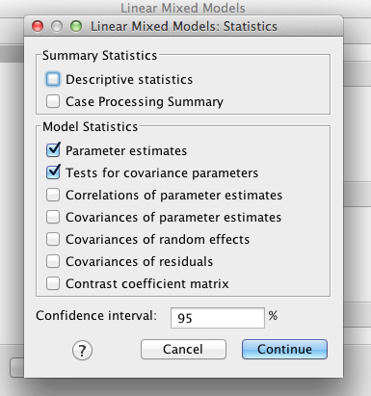

Under EM means, move the variables over (notice you won’t get the time one).

You can actually do post hoc tests here … useful if you have more than two levels, but only for main effects of categorical variables.

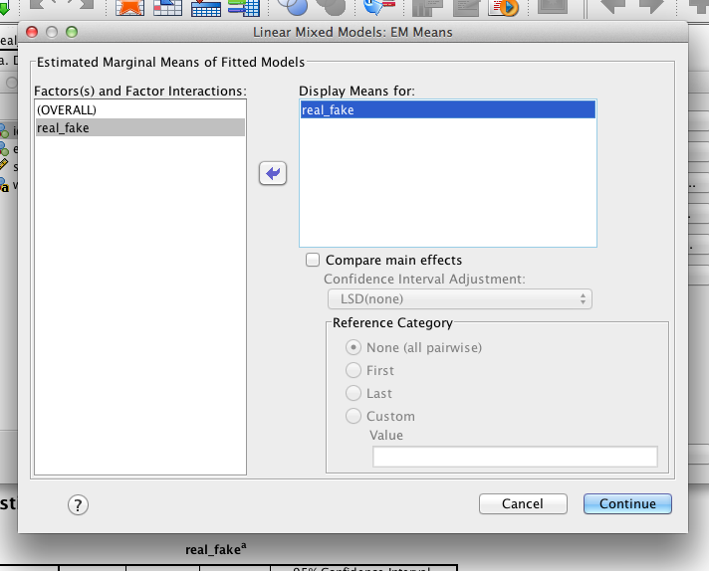

Hit ok!

Picking a model:

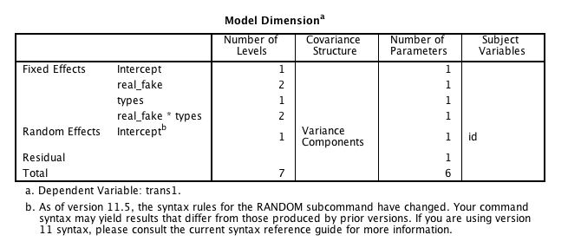

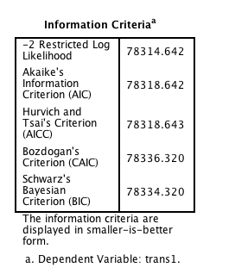

You want to run different types of covariance structures (especially if it crashes).

1. You want to make a chart for the total components and the chi square:

|  |  |  |  |  |
| --- | --- | --- | --- | --- |
| Types of covariance | Total parameters  Number of parameters column > total row | Chi Square  -2 restricted log likelihood | Difference | Cut Off |
| UN |  |  |  |  |
| VC (under covariance structure) | 6 | 78314.642 | Subtract total parameters UN – VC  Subtract chisquares as well | Find a chisquare value p<.05 with the df = difference column |
| ID | 6 | 78314.642 | Subtract total parameters VC – ID  Subtract chisquares as well |  |

Un – unstructured, VC = variance components, ID = identity matrix … these are increasingly complex…but honestly, I can’t remember all the rules to each one…but I know you want to use the one with the lowest chi-square (that didn’t give you errors or crash). To get other models, change it on the RANDOM selection page. If the chi-square value is OVER the cut off score, the model is significantly WORSE (bad). So you want to use the one with lower chi-squares.

(I think the way my experiment was set up, we really couldn’t do this, it is more for a time based thing).

Use the output from the model you choose for the rest:

Under fixed effects:

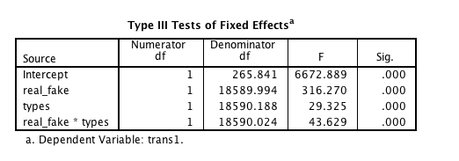

It’s an ANOVA box! Interpret it just like one. So my main effects and interactions are significant.

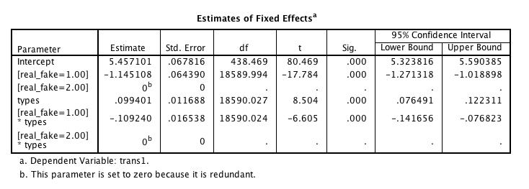

This box is actually just like a coefficients box in regression. So:

* “slope” for fake to real = -1.145, which means that I have a 1.145 difference in means, and the real one is higher (I looked at the marginal means to figure this out).

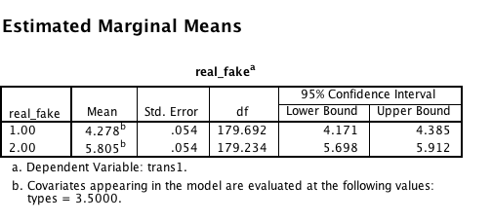

(note that the differences won’t correspond exactly because of estimate stuff – kind of like ANCOVA).

* Types was significant, since I treated this as continuous, it’s saying that for each step up in difficulty, people are rating them 0.099 points higher.
* And then the interaction is significant (yay!), but we need to post hoc (boo).

The easiest thing to do with categorical variables is to split the file and run each group separately to look at their slopes for the time (or continuous or other categorical variable).

Data > split file > categorical variable.

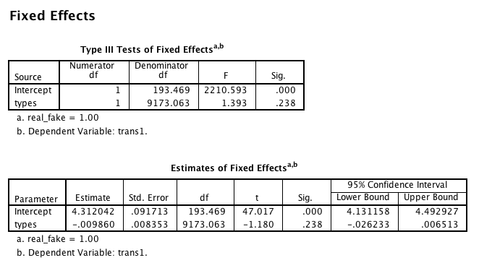

For this group (fake words) – type was not a significant variable.

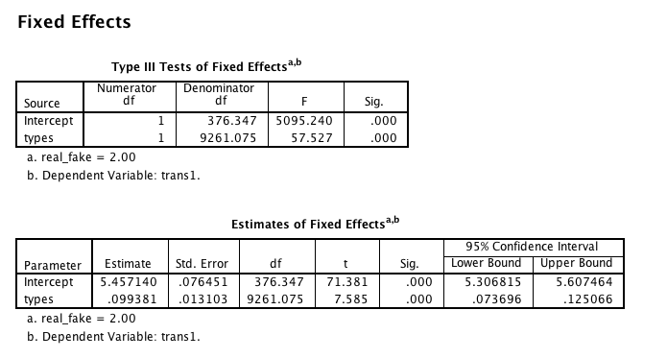

For this group (real words), type was a significant variable – interpret just like a regression coefficient (and report it like one).